Final mark awarded ______


FACULTY OF COMPUTING, ENGINEERING and SCIENCE Assessment Cover Sheet and Feedback Form 2017/18

Module Code: | Module Title: |  |  | Lecturer:
NG4D900 | MEng Major Group Project |  |  | Guoping Liu
Assignment No: | No. of pages in total including |  |  | Maximum Word Count:
1 | this page: 10 |  |  | 15000
Assignment Title: |  | Report
Tasks:
Date Set: |  |  | Submission Date: |  | Feedback Date:
27/09/2017 |  |  | 25/04/2018 |  | 09/05/2018

Section A: Record of Submission

Record of Submission and Plagiarism Declaration

I declare that this assignment is my own work and that the sources of information and material I have used (including the internet) have been fully identified and properly acknowledged as required in the referencing guidelines provided.

Fit to Sit Policy

The University operates a fit to sit policy whereby you, in submitting or presenting yourself for any assessments, are declaring that you are fit to sit the assessment. You cannot subsequently claim that your performance in that assessment was affected by extenuating circumstances.

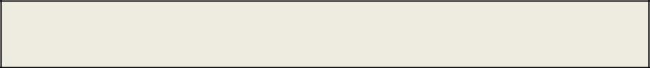

Student Number:

You are required to acknowledge that you have read the above statements by writing your student number(s) above.

(If this is a group assignment, please provide the student numbers of ALL group members)

Details of Submission
IT IS YOUR RESPONSIBILITY TO KEEP A RECORD OF ALL WORK SUBMITTED.

Work should be submitted as detailed in your student handbook. You are responsible for checking the method of submission.

Late Submission – Work must be submitted by the submission date. If you fail to do this,

you will be allowed a further five working days to submit the work but the work will be awarded a maximum mark of 40%. If you fail to submit work within five working days of the submission date, you will be deemed to have failed this assessment which will be given a mark of 0%. However see extenuating circumstances below.

Extenuating Circumstances: if there are any exceptional circumstances that may have affected your ability to undertake or submit this assignment, make sure you contact your
Advice Shop and also see either http://cesstudents.southwales.ac.uk/Ext_circs/ (Trefforest) or http://glyntaffcampus.southwales.ac.uk/advice_shop/Extenuating_Circumstances/ (Glyntaff)

Section B : Marking and Assessment

This assignment will be marked out of 100%

This assignment contributes to100% of the total module marks.

This assignment is bonded / non- bonded. Details :

It is estimated that you should spend approximately

20 hours on this assignment.

Learning Outcomes

This assignment addresses the following learning outcome(s) of the module:

- Work effectively as part of a multi-disciplinary team in developing and implementing a solution to a complex, industrially relevant, major technical problem, communicating effectively with a team members and, if appropriate, personnel from the sponsoring industry.

- Demonstrate a critical and conceptual understanding of all aspects of the work, and contribute to both the production of a detailed technical report, and a concise technical presentation.

- Demonstrate a critical and conceptual understanding of all aspects of the work, and contribute to both the production of a detailed technical report, and a concise technical presentation.

Marking Scheme |  | Marks | Marks
 |  | Available | Awarded
1. | See page 5
2.
3.
etc.

Assessment Criteria

Performance Level | Criteria

Fail

(<40%)

3rd Class / PASS
(40%-49%)

Lower 2nd Class / PASS
(50%-59%)

Upper 2nd Class / MERIT

(60%-69%)

1st Class / DISTINCTION
(70% +)

Section C : Marker’s Feedback

Lecturer’s Comments:

………………………………………………………………………………………………………………

………………………………………………………………………………………………………………

………………………………………………………………………………………………………………

………………………………………………………………………………………………………………

………………………………………………………………………………………………………………

………………………………………………………………………………………………………………

………………………………………………………………………………………………………………

………………………………………………………………………………………………………………

………………………………………………………………………………………………………………

………………………………………………………………………………………………………………

………………………………………………………………………………………………………………

………………………………………………………………………………………………………………

………………………………………………………………………………………………………………

Areas to concentrate on next time:

Report structure | Research | Content | Team work
Referencing | Presentation
Lecturer’s signature: |  | Date: | Mark awarded:
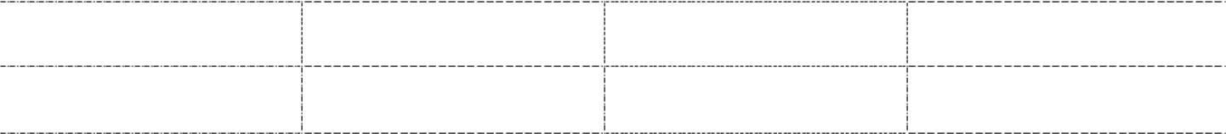

All marks are subject to confirmation by the Assessment Boards

A

